

**FOR IMMEDIATE RELEASE**

Contact: Kathryn Thompson • [kathryn@thepcbs.org](mailto:kathryn@thepcbs.org)  
Office: (425) 278-0248 • Mobile: (425) 765-2808

**Pacific Coast Banking School Names Joan Reukauf   
New President and CEO**

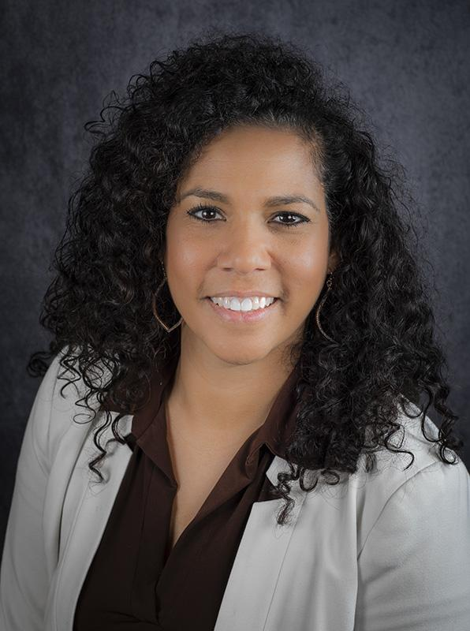

**Bellevue, WA, June 3, 2024** – The board of directors of Pacific Coast Banking School (PCBS) is pleased to announce the selection of Joan Reukauf as its incoming President. Reukauf is succeeding PCBS President and CEO, Gretchen Claflin, who plans to retire at the end of 2024 when Reukauf will assume the title of President and CEO.

Reukauf comes to PCBS with deep connections to the school and a wealth of experience from her 20+ years in the banking industry. A PCBS graduate and current instructor, Reukauf most recently served as Chief Operating Officer of People’s Bank of Commerce after a successful merger with Willamette Community Bank where she served as President and CEO. Reukauf also teaches for the American Banking Association and for Willamette University, where she received her MBA.

“I am honored and excited to lead PCBS as the new President and CEO,” Reukauf said. “This institution has always had a very special place in my heart, and I am committed to building upon our very strong foundation to drive innovation, growth, and success. I look forward to embarking on this journey and contributing to the ongoing legacy of excellence forged by those before me along with the talented team at PCBS.”

Reukauf was selected after an extensive search process managed by the executive search firm, Korn Ferry. Her experience as both a banker and an educator were considered by the search committee to be key in making their final decision.

“Joan’s ties to PCBS and her experience as an instructor and as a leader in the banking industry make her uniquely qualified to lead PCBS into the future,” said Board Chairman, Jack Heath. “Joan’s experience and energy will drive new initiatives that will benefit future generations of leaders in the banking and financial services industry.”

Retiring President and CEO, Gretchen Claflin, added, “I am thrilled that the board has selected Joan to carry on the tradition of excellence that is the hallmark of PCBS. As the Premier National Graduate School of Banking, PCBS attracts the best and brightest future leaders in the industry. I’ve had the privilege of working with Joan as a PCBS instructor over the years and I am confident that under her leadership the school will continue to thrive in providing the best banking education in the industry.”

**About Pacific Coast Banking School**

Since 1938, Pacific Coast Banking School, in partnership with the Foster School of Business at the University of Washington, has offered a rigorous graduate-level educational program focused on the banking industry. Leading industry experts and academicians teach the ***Business of Banking, Innovation, and Executive Leadership*** through a cutting-edge curriculum designed to prepare graduates to rise as leaders in the financial services industry. The PCBS family includes over 13,000 bankers, with hundreds serving in key leadership roles in banking across the country. For more information, visit [www.thepcbs.org](http://www.thepcbs.org/).

# # #

Pacific Coast Banking School • 2223 112th Ave NE, Suite 200 • Bellevue, WA 98004 • Phone: 425.278.0250